Domestic Abuse Resource Order Form

Resource | Image | Number requested
A4 Male Victim Poster
A4 ‘No one has the right to make you feel that you can’t speak out’ Poster
LGBT+ Poster | 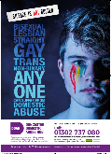
Domestic Abuse Hub Leaflet | 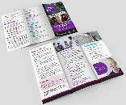
MARAC Leaflet | 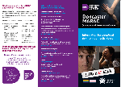
Safety Booklet

Practitioner booklet

Stalking and harassment A4 and A3 posters | 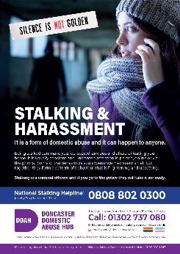 | Please specify whether you want A4 or A3
Stalking and harassment A4 and A3 posters | 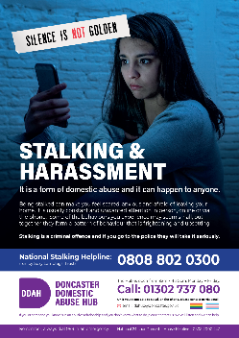 | Please specify whether you want A4 or A3
Familial abuse | 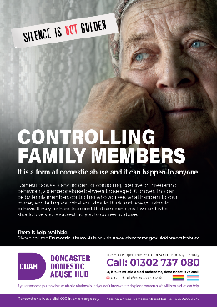 | Please specify whether you want A4 or A3
Talk to the badge - Nurse | 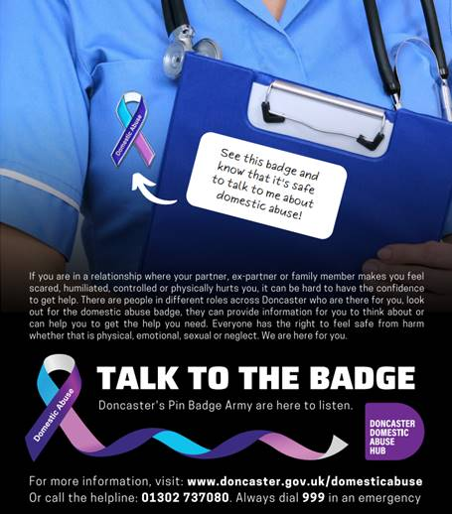
Talk to the badge – Male shirt
Talk to the badge – woman suit
Talk to the badge – man workgear | 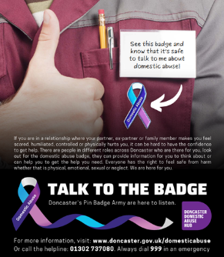
Talk to the badge - hoodie
Barcodes – 65 stickers per page | 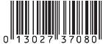 | [ ] pages of stickers
New resources under development:
- Learning Disability/easy read leaflets

Please do not order more than you need. Publicity material will be changed on a regular basis to keep the message alive and ensure they contain the correct information.

Large order will be available for collection from the Mary Woollett Centre. Smaller orders can be posted. Please provide contact details so that collection can be arranged when ready:

Name:
Job Title:

Agency:
Delivery address (for smaller orders):
Email address:
Telephone Number:
How do you intend to use the resources?

Where will they be displayed?

Please email the completed form to Sophie.bishop@doncaster.gov.uk

